Georgia Avenue Concept Study Update

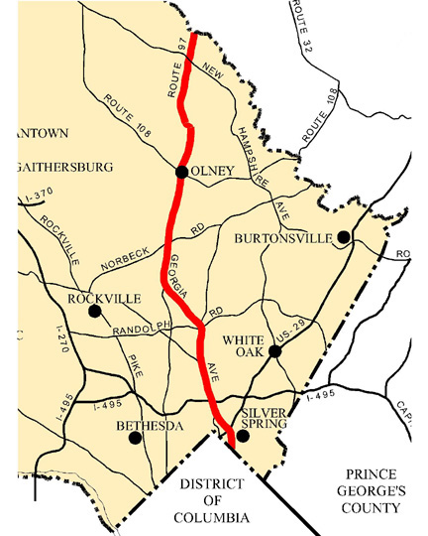
What: Community meeting on the Georgia Avenue Concept Study (second public meeting)
When: 7 to 9 p.m., Tuesday, February 5
Who: Montgomery County Planning Department
Where: Saddlebrook Park Police Headquarters
12751 Layhill Road, Silver Spring
The Montgomery County Planning Department invites residents, workers and others interested in the Georgia Avenue area to attend a meeting that will provide a status report on a study of Georgia Avenue between the District of Columbia and the Howard County line.

Planning staff will present the highlights of the community input gained during a kick-off meeting held November 27 as well as information assimilated during staff’s work to date. In addition, staff will present an outline of the topics expected to be analyzed in more detail as well as a schedule for the remainder of the study.

The concept study takes a big-picture look at Georgia Avenue. Planners will define appropriate land uses and develop a framework that guides upcoming planning efforts, including the sector plans for the Wheaton and Glenmont Metro stations. It will focus on where future growth should occur, analyzing a variety of development scenarios for some of the large commercial properties along the road. Planners will consider urban design elements that could enhance Georgia Avenue’s appearance as well as protect residents – particularly pedestrians – through better-designed sidewalks, crosswalks, bus shelters and landscaping.

Please contact Khalid Afzal at (301) 495-4650 or at khalid.afzal@mncppc-mc.org to get more information about the study or schedule a meeting with your civic association.

The Montgomery County Planning Department provides access to language interpretation services for community meetings and other programs. If you, or someone you know, needs language interpretation services, please contact Alexandra Teaff, 301-495-4600, at least five days prior to the meeting.

